Progressive Education Society's

**Modern College of Engineering, Pune**

**MCA Department**

**A.Y.2022-23**

**(310902) Data Structure and Algorithm Laboratory**

***********************************************************************************************

Class: FY-MCA Shift /Div: A Batch: F2 Roll Number: 51043

Name: Vanessa Reetu Prashant More Assignment No: 1 Date of Implementation: 15/12/2022

***********************************************************************************************

Q1.Write a program to find mean of n numbers using arrays.

Program: #include<stdio.h>

#include<conio.h>

int main(){

int num, i, max,sum=0;

int arr[100];

//clrscr();

printf("Enter number of elements: ");

scanf("%d",&num);

for(i=0;i<num;i++){

printf("Enter element No. %d: ",i+1);

scanf("%d",&arr[i]);

}

for(i=0; i<num; i++){

sum = sum + arr[i];

}

printf("Sum of Array elements = %d ",sum);

getch();

return 0;

}

Output: Enter number of elements: 4

Enter element No. 1: 24

Enter element No. 2: 21

Enter element No. 3: 32

Enter element No. 4: 12

Sum of Array elements = 89

Output Screenshot:

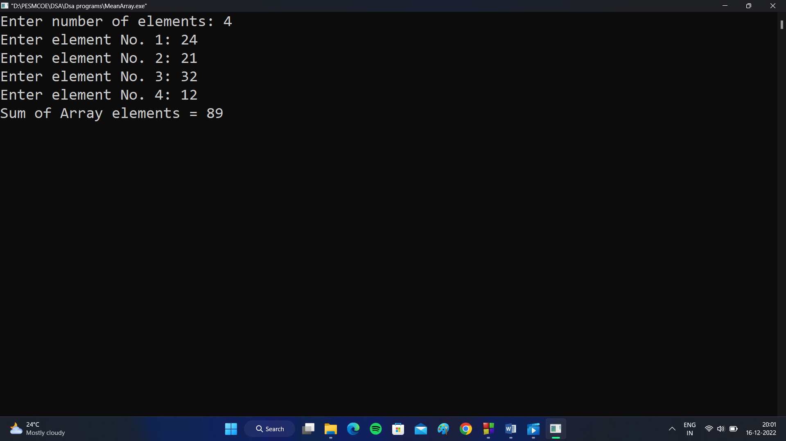

Q2. Write a program to interchange the smallest & largest no of n numbers using arrays.

Program:

#include<stdio.h>

#include<conio.h>

int main(){

int num, i, max, x, y, min;

int arr[100];

//clrscr();

printf("Enter number of elements: ");

scanf("%d",&num);

for(i=0;i<num;i++){

printf("Enter element No. %d: ",i+1);

scanf("%d",&arr[i]);

}

max =arr[0];

for(i=0; i<num; i++){

if(max < arr[i]){

max = arr[i];

y = i;

}

}

min = arr[0];

for(i=0; i<num; i++){

if(min > arr[i]){

min = arr[i];

x = i;

}

}

printf("Original Array: ");

for(i=0;i<num;i++){

printf(" %d ",arr[i]);

}

for(i=0; i<num; i++){

if(i==y){

arr[i]=min;

}

if(i==x){

arr[i]=max;

}

}

printf("\nSwapped Array: ");

for(i=0;i<num;i++){

printf(" %d ",arr[i]);

}

printf("\nMaximum Number = %d ",max);

printf("\nMinimum Number = %d ",min);

getch();

return 0;

}

Output: Enter number of elements: 5

Enter element No. 1: 24

Enter element No. 2: 31

Enter element No. 3: 42

Enter element No. 4: 6

Enter element No. 5: 32

Original Array: 24 31 42 6 32

Swapped Array: 24 31 6 42 32

Maximum Number = 42

Minimum Number = 6

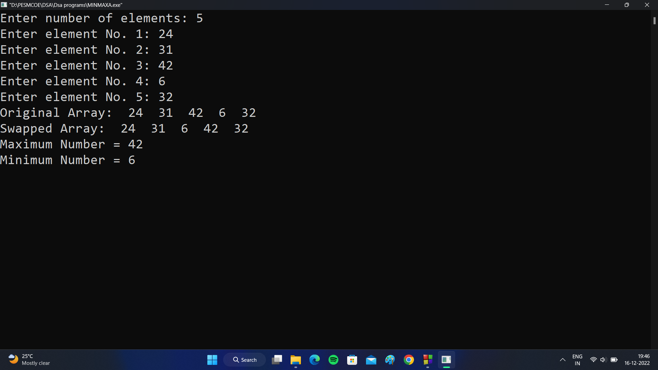Output Screenshot:

Q3. Write a program to delete a no from an array which is already sorted in ascending order.

Program: #include<stdio.h>

#include<conio.h>

int main(){

int num, pos, i,j,x;

int arr[100];

printf("Enter number of elements: ");

scanf("%d",&num);

for(i=0;i<num;i++){

printf("Enter element No. %d: ",i+1);

scanf("%d",&arr[i]);

}

//Sorting array

for(i = 0; i<num; i++){

for(j = i+1; j<num;j++){

if(arr[i]>arr[j]){

x = arr[i];

arr[i] = arr[j];

arr[j] = x;

}

}

}

printf("\nSorted Array: \n");

for(i=0;i<num;i++){

printf(" %d ",arr[i]);

}

//Deleting element at a position

printf("\nEnter Position of element to delete: ");

scanf("%d",&pos);

if (pos>=num){

printf("\nElement does not exist");

}

else{

for (i=pos-1; i<num-1; i++){

arr[i]=arr[i+1];

}

printf("\nArray after deleting number: \n");

// display the final array

for (i = 0; i< num - 1; i++)

{

printf (" %d ", arr[i]);

}

}

getch();

return 0;

}

Output: Enter number of elements: 5

Enter element No. 1: 23

Enter element No. 2: 54

Enter element No. 3: 16

Enter element No. 4: 43

Enter element No. 5: 22

Sorted Array:

16 22 23 43 54

Enter Position of element to delete: 4

Array after deleting number:

16 22 23 54

Output Screenshot:

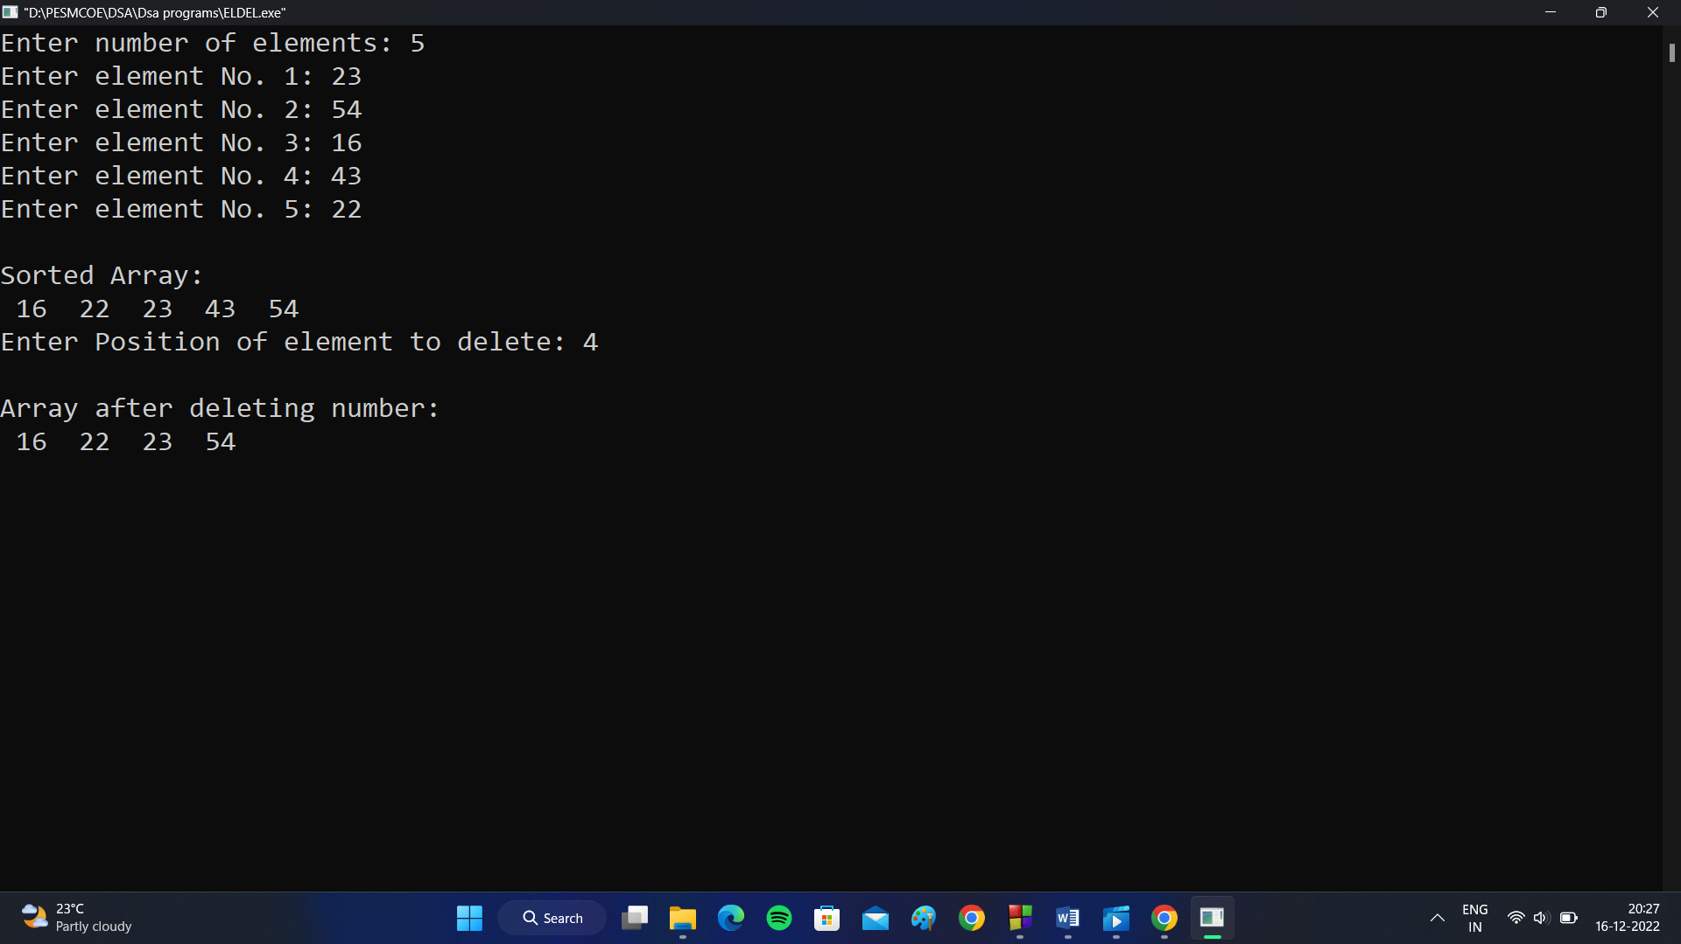

Q4. Write a program to read and display a 3*3 matrix.

Program: #include<stdio.h>

#include<conio.h>

int main(){

int i,j;

int matrix[3][3];

printf("Enter array elements:\n");

for(i=0;i<3;i++){

for(j=0;j<3;j++){

printf("Enter element for [%d][%d]:",i,j);

scanf("%d",&matrix[i][j]);

}

}

printf("\n\nMATRIX IS:\n");

for(i=0;i<3;i++){

for(j=0;j<3;j++){

printf(" %d ",matrix[i][j]);

}

printf("\n");

}

getch();

return 0;

}

Output: Enter array elements:

Enter element for [0][0]:11

Enter element for [0][1]:12

Enter element for [0][2]:13

Enter element for [1][0]:14

Enter element for [1][1]:15

Enter element for [1][2]:16

Enter element for [2][0]:17

Enter element for [2][1]:18

Enter element for [2][2]:19

MATRIX IS:

11 12 13

14 15 16

17 18 19

Output Screenshot:

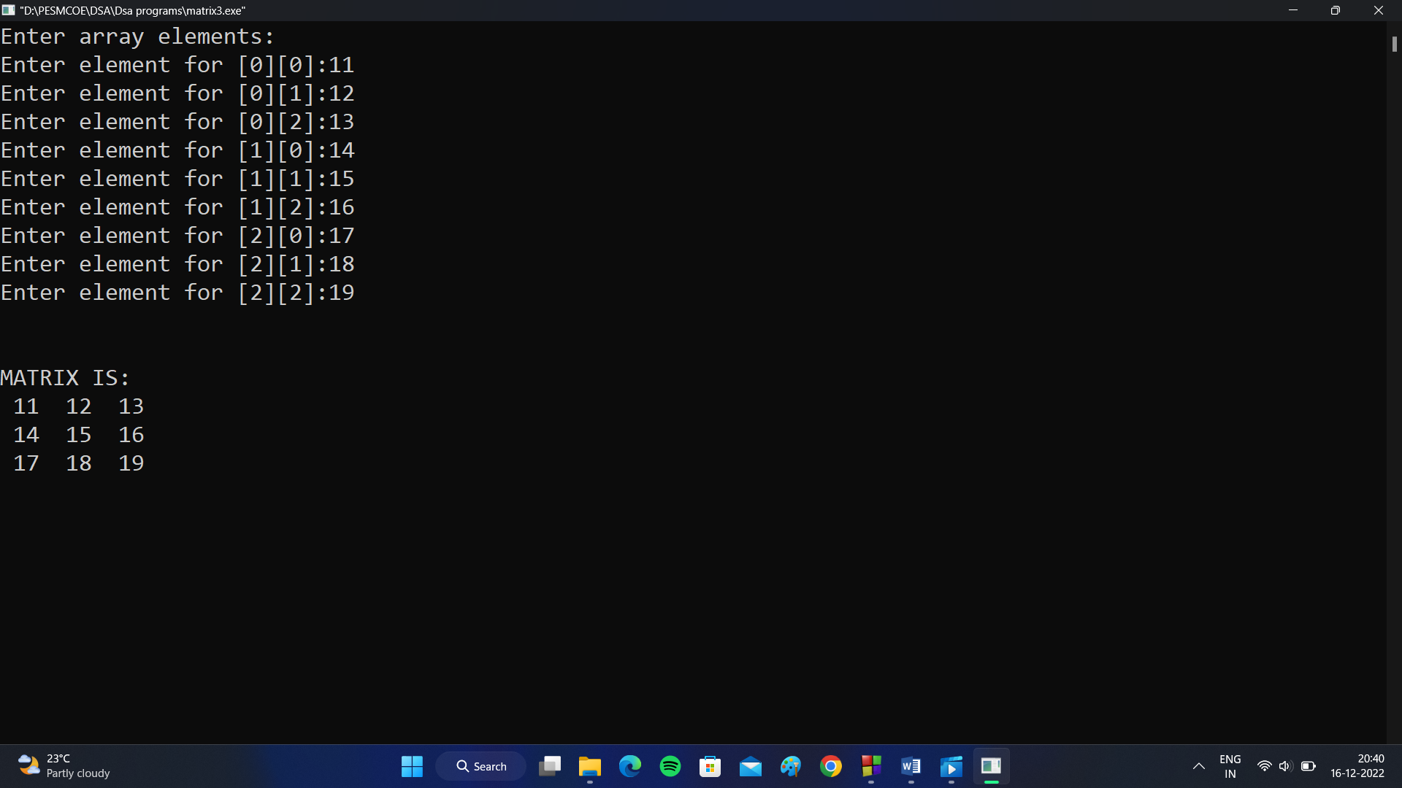

Q5. Write a program to find transpose of a given matrix.

Program: #include<stdio.h>

#include<conio.h>

int main(){

int i,j,row,col;

int matrix[50][50];

printf("Enter number of rows: ");

scanf("%d",&row);

printf("Enter number of columns: ");

scanf("%d",&col);

printf("Enter matrix elements:\n");

for(i=0;i<row;i++){

for(j=0;j<col;j++){

printf("Enter element for [%d][%d]:",i,j);

scanf("%d",&matrix[i][j]);

}

}

printf("\n\nMATRIX IS:\n");

for(i=0;i<row;i++){

for(j=0;j<col;j++){

printf(" %d ",matrix[i][j]);

}

printf("\n");

}

printf("\n\nTRANSPOSE OF MATRIX IS:\n");

for(i=0;i<col;i++){

for(j=0;j<row;j++){

printf(" %d ",matrix[j][i]);

}

printf("\n");

}

getch();

return 0;

}

Output: Enter number of rows: 2

Enter number of columns: 3

Enter array elements:

Enter element for [0][0]:1

Enter element for [0][1]:2

Enter element for [0][2]:3

Enter element for [1][0]:4

Enter element for [1][1]:5

Enter element for [1][2]:6

MATRIX IS:

1 2 3

4 5 6

TRANSPOSE OF MATRIX IS:

1 4

2 5

3 6

Output Screenshot:

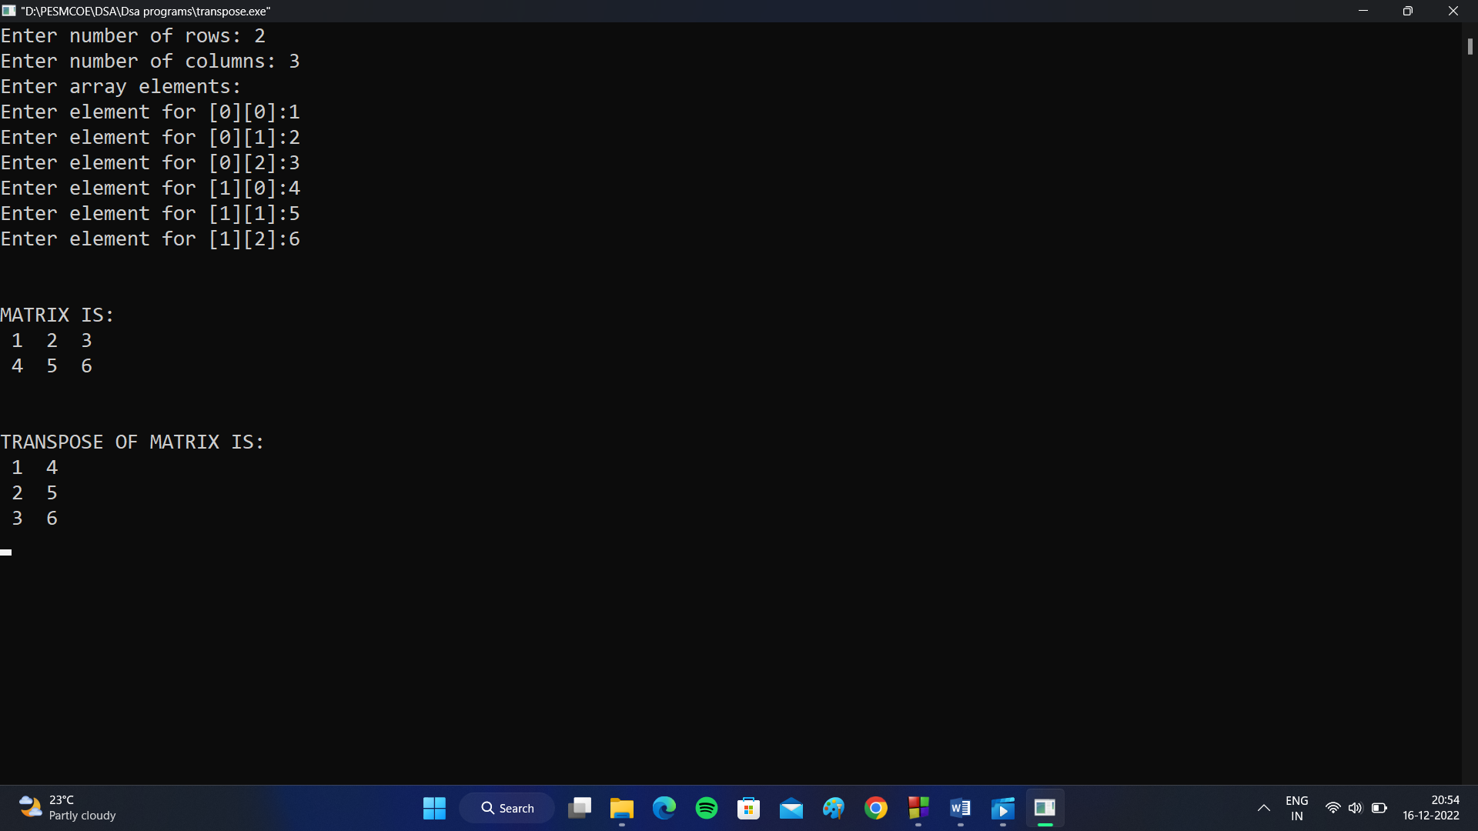

Q6. Write a program to perform transpose of a sparse matrix.

Program: #include<stdio.h>

#include<conio.h>

int main(){

int arr[3][3]={{0,10,0},{20,0,0},{0,0,30}};

int i,j, count=0,x=1,y,z;

int sparse[10][3];

int transpose[10][3];

for(i=0;i<3;i++){

for(j=0;j<3;j++){

printf(" %d ",arr[i][j]);

}

printf("\n");

}

for(i=0;i<3;i++){

for(j=0;j<3;j++){

if(arr[i][j]!=0){

sparse[x][0]=arr[i][j];

sparse[x][1]=i;

sparse[x][2]=j;

x++;

}

}

}

printf("\nSparse Matrix:\n");

for(y=1;y<x;y++){

for(z=0; z<3; z++){

printf(" %d ",sparse[y][z]);

}

printf("\n");

}

printf("\nTranspose of Sparse Matrix:\n");

for (y=0; y<x; y++){

for(z=0; z<3; z++){

transpose[y][0]=sparse[y][0];

transpose[y][1]=sparse[y][2];

transpose[y][2]=sparse[y][1];

}

}

for (y=1; y<x; y++){

for(z=0; z<3; z++){

printf(" %d ",transpose[y][z]);

}

printf("\n");

}

getch();

return 0;

}

Output: 0 10 0

20 0 0

0 0 30

Sparse Matrix:

10 0 1

20 1 0

30 2 2

Transpose of Sparse Matrix:

10 1 0

20 0 1

30 2 2

Output Screenshot:

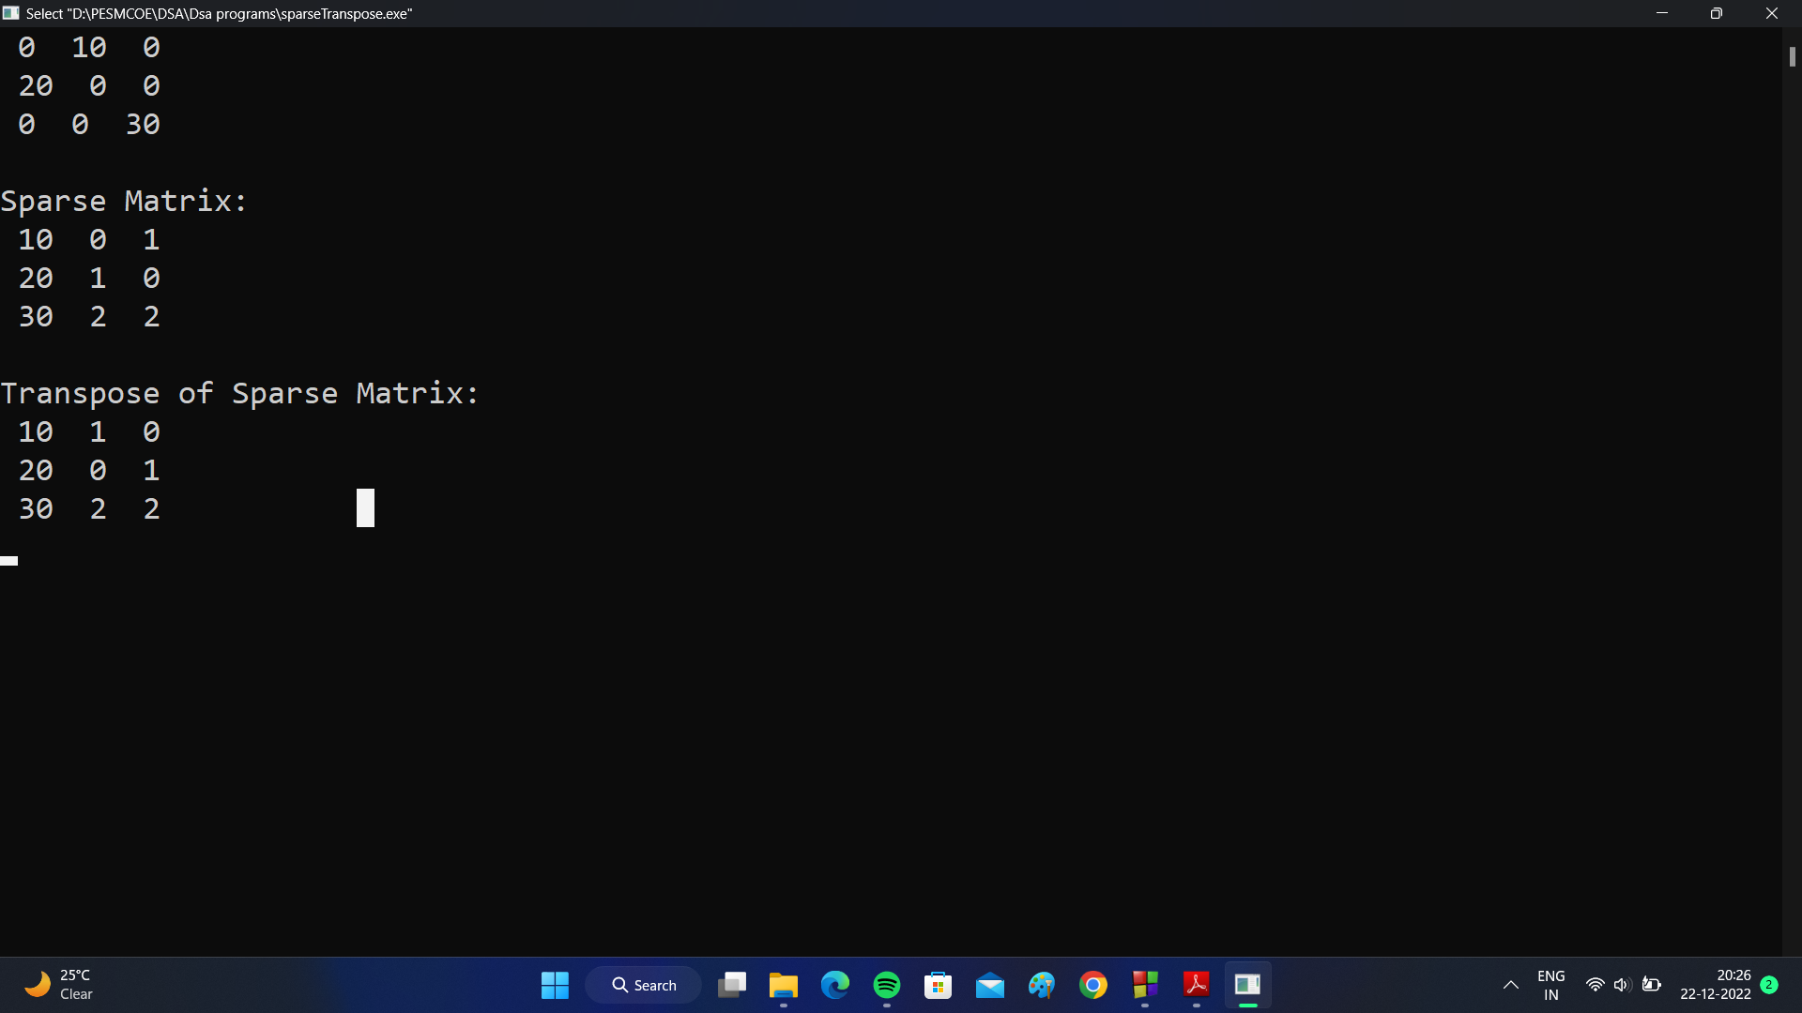

Q7. Write a program to perform addition of two sparse matrices.

Program: #include<stdio.h>

#include<conio.h>

int main(){

int arr1[50][50];

int arr2[50][50];

int arr3[50][50];

int i,j, count=0,x=1,y,z, row,col;

int sparse1[50][3];

int sparse2[50][3];

int sparse3[50][3];

printf("Enter number of rows: ");

scanf("%d",&row);

printf("Enter number of columns: ");

scanf("%d",&col);

printf("\nEnter elements for Matrix 1:\n");

for(i=0;i<row;i++){

for(j=0;j<col;j++){

printf("Enter element for [%d][%d]:",i,j);

scanf("%d",&arr1[i][j]);

}

}

printf("\nEnter elements for Matrix 2:\n");

for(i=0;i<row;i++){

for(j=0;j<col;j++){

printf("Enter element for [%d][%d]:",i,j);

scanf("%d",&arr2[i][j]);

}

}

printf("\nMatrix 1:\n");

for(i=0;i<row;i++){

for(j=0;j<col;j++){

printf(" %d ",arr1[i][j]);

}

printf("\n");

}

printf("\nMatrix 2:\n");

for(i=0;i<row;i++){

for(j=0;j<col;j++){

printf(" %d ",arr2[i][j]);

}

printf("\n");

}

//ADDITION OF MATRICES

for(i=0;i<row;i++){

for (j=0;j<col;j++){

arr3[i][j] = arr1[i][j] + arr2[i][j];

}

}

printf("\nMatrix 3:\n");

for(i=0;i<row;i++){

for(j=0;j<col;j++){

printf(" %d ",arr3[i][j]);

}

printf("\n");

}

for(i=0;i<row;i++){

for(j=0;j<col;j++){

if(arr1[i][j]!=0){

sparse1[x][0]=arr1[i][j];

sparse1[x][1]=i;

sparse1[x][2]=j;

x++;

}

}

}

printf("\nSparse Matrix 1:\n");

for(y=1;y<x;y++){

for(z=0; z<3; z++){

printf(" %d ",sparse1[y][z]);

}

printf("\n");

}

x=1;

for(i=0;i<row;i++){

for(j=0;j<col;j++){

if(arr2[i][j]!=0){

sparse2[x][0]=arr2[i][j];

sparse2[x][1]=i;

sparse2[x][2]=j;

x++;

}

}

}

printf("\nSparse Matrix 2:\n");

for(y=1;y<x;y++){

for(z=0; z<3; z++){

printf(" %d ",sparse2[y][z]);

}

printf("\n");

}

x=1;

for(i=0;i<row;i++){

for(j=0;j<col;j++){

if(arr3[i][j]!=0){

sparse3[x][0]=arr3[i][j];

sparse3[x][1]=i;

sparse3[x][2]=j;

x++;

}

}

}

printf("\nAddition of Sparse Matrix :\n");

for(y=1;y<x;y++){

for(z=0; z<3; z++){

printf(" %d ",sparse3[y][z]);

}

printf("\n");

}

getch();

return 0;

}

Output: Enter number of rows: 2

Enter number of columns: 3

Enter elements for Matrix 1:

Enter element for [0][0]:1

Enter element for [0][1]:2

Enter element for [0][2]:3

Enter element for [1][0]:0

Enter element for [1][1]:0

Enter element for [1][2]:0

Enter elements for Matrix 2:

Enter element for [0][0]:1

Enter element for [0][1]:2

Enter element for [0][2]:7

Enter element for [1][0]:7

Enter element for [1][1]:0

Enter element for [1][2]:0

Matrix 1:

1 2 3

0 0 0

Matrix 2:

1 2 7

7 0 0

Matrix 3:

2 4 10

7 0 0

Sparse Matrix 1:

1 0 0

2 0 1

3 0 2

Sparse Matrix 2:

1 0 0

2 0 1

7 0 2

7 1 0

Addition of Sparse Matrix :

2 0 0

4 0 1

10 0 2

7 1 0

Output Screenshot:

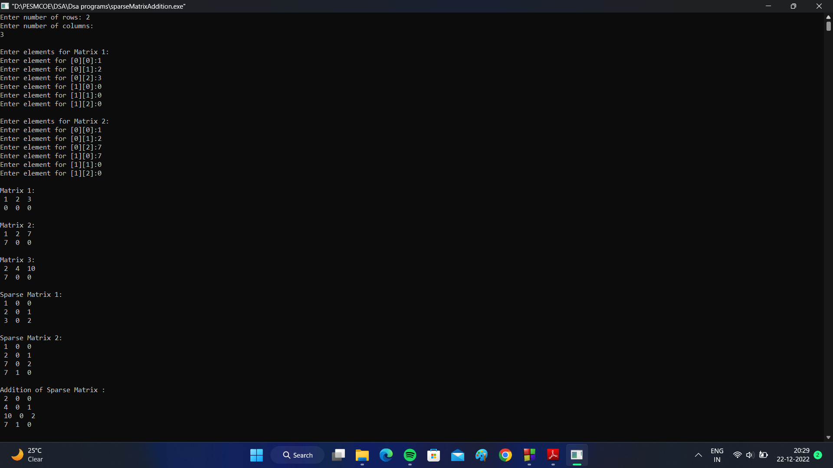



Q8. Write a program to perform addition of a two polynomial expressions using arrays.

Program: #include<stdio.h>

#include<conio.h>

int main(){

int poly1[50], poly2[50], polyadd[50];

int coeffiecient, hdegree1, hdegree2, coef,deg;

int i,j;

//For Polynomial 1

printf("Enter Highest degree for polynomial 1: ");

scanf("%d",&hdegree1);

printf("Enter number of coefficients: ");

scanf("%d",&coeffiecient);

for (j=0;j<hdegree1+1;j++){

poly1[j]=0;

}

for (i=0; i<coeffiecient; i++){

printf("Enter coefficient: ");

scanf("%d",&coef);

printf("Enter degree: ");

scanf("%d",&deg);

poly1[deg]= coef;

}

for (i=hdegree1;i>=0;i--){

if(poly1[i]!=0){

printf("%dx^%d + ", poly1[i],i);

}

}

//For Polynomial 2

printf("\nEnter Highest degree for polynomial 2: ");

scanf("%d",&hdegree2);

printf("Enter number of coefficients: ");

scanf("%d",&coeffiecient);

for (j=0;j<hdegree2+1;j++){

poly2[j]=0;

}

for (i=0; i<coeffiecient; i++){

printf("Enter coefficient: ");

scanf("%d",&coef);

printf("Enter degree: ");

scanf("%d",&deg);

poly2[deg]= coef;

}

for (i=hdegree2;i>=0;i--){

if(poly2[i]!=0){

printf("%dx^%d + ", poly2[i],i);

}

}

if (hdegree1>hdegree2){

deg = hdegree1;

}else if(hdegree2>hdegree1){

deg = hdegree2;

}else{

deg = hdegree1;

}

for (j=0;j<=deg;j++){

polyadd[j]=0;

}

for (i=0; i<=deg; i++){

polyadd[i] = poly1[i] + poly2[i];

}

printf("\nAddition of Polynomials: \n");

for (i=deg+1; i>=0 ; i--){

if(polyadd[i]!=0){

printf("%dx^%d +", polyadd[i],i);

}

}

getch();

return 0;

}

Output: Enter Highest degree for polynomial 1: 3

Enter number of coefficients: 2

Enter coefficient: 3

Enter degree: 3

Enter coefficient: 4

Enter degree: 2

3x^3 + 4x^2 +

Enter Highest degree for polynomial 2: 5

Enter number of coefficients: 3

Enter coefficient: 2

Enter degree: 3

Enter coefficient: 4

Enter degree: 5

Enter coefficient: 3

Enter degree: 1

4x^5 + 2x^3 + 3x^1 +

Addition of Polynomials:

4x^5 + 5x^3 + 4x^2 + 3x^1 +

Output Screenshot:

-----------------------------------------------------------------------------------------------------------------------------------------------